Numerical Analysis
Task 2. Linear algebraic systems
- LU-decomposition of matrix X by partial pivoting of rows (max column elem; permutate rows).
If A [n x m], LU-decomposition via partial pivot is done column by column, but elimination can be done only while:
there are columns left (i < m)
there are rows below to eliminate (i < n)
So, the max number of meaningful iterations is min(n ,m).
- det(A) = (det(L)*det(U))/det(P); det(L) = 1, det(U) = {произведение элементов главной диагонали} => det(A) = П(u_ii)/det(P); det(P) = (-1)^s; s = 1 if the number of swaps in the permuation matrix P was even, s = -1 — uneven.
- PA = LU =>
A = P^-1 * L* U =>
P^T * L * U => A^-1 = (P^T * L * U)^-1 =>
A^-1 = U^-1 * L^-1 * P.
We don't explicitly solve U^-1 and L^-1 instead we solve it with forward substitution for Ly = PE_i and backward substitution Ux = y. The vector x is an i-th column of A^-1 .
The i-th equation row-wise: l_ii * y_i + [sum (j=0 in range(i)) l_ij * y_j] = (Pb)_i. Ex.:
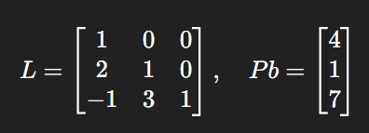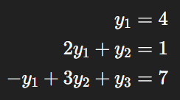
Analogue: The i-th equation row-wise: u_ii * x_i + [sum (j=i+1 in range(n)) u_ij * x_j] = y_i.
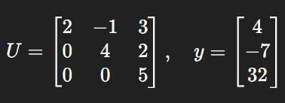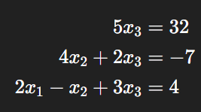
- Find inverse matrix for A: b = e_i => L(Ux_i) = Pe_i for each column x_i of A_inv. Therefore, to find inverse matrix, solve one system for each basis vector.
- Condition number. In SofLE Ax = b, matrix A is known exactle, but the right part b has an irremovable error
δb => A(x + δx) = b + δb =>
Absolute error: Ax - Ax - Aδx = b - b - δb => Aδx = δb => δx = A_inv * δb.
Norm: ||δb|| = ||A_inv * δb|| <= ||A_inv|| * ||δb||.
Express via relative error:
b = Ax =>
||b|| = ||Ax|| <= ||A|| * ||δb|| =>
||x|| >= ||b|| / ||A||.
Divide absolute error by relative error: ||δb|| / ||x|| <= ||A|| * ||A_inv|| * ||δb|| / ||b||, где ν(A) = ||A|| * ||A_inv|| — число обусловленности.
Norm ||A||_1 = max_i (sum_j (|a_ij|) ) (max sum of abs by columns) for ||A|| * ||A_inv||.

- Theorem to Generate Singular Matrices. Let A be a matrix of order m × k and B be a matrix of order k × m, where m > k. Then, the product A*B, which is an m × m matrix, is always singular. The intuition is that the rank of the product A*B cannot exceed k, which is less than m, so A*B cannot be full-rank and thus must be singular.
For a system Ax = b, the possible outcomes are:
- No solution. The system is inconsistent: rank(A) != rank([A | b])
a row like [0 0 … 0 | b_i] and b_i != 0 => no solution
- One solution. The system is consistent: rank(A) = n (A: [n x n]). Every variable is a pivot variable
- Infinitely many solutions. The system is consistent, but rank(A) < n. There are free variables.
- Householder reflections to make QR-decomposition remove a whole column at once, require fewer transformations and are best for dense matrices. It’s faster than Givens rotations.
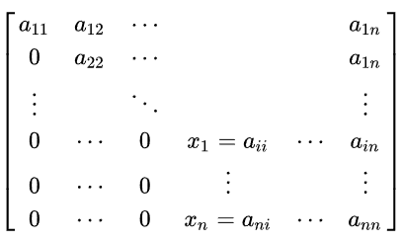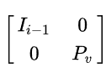
The first i-1 rows/cols are left unchanged; only the lower block P_v is transformed. P_v is the Householder reflector acting on the subvector starting at row i.
Algorithm:
- Q = I, R= A
- For each column i:
  - take the column segment below the diagonal
  - build a Householder reflector H_i
  - apply it to zero out entries below the diagonal in column i
- Multiply all reflectors together to form Q
Because H_i is orthogonal, H_i * (H_i)^T = I, their product is also orthogonal.
If R = H_t * … * H_1 * A, then A = (H_1)^T * … * (H_t)^T * R. So Q = (H_1)^T * … * (H_t)^T,
t = n-1. Because Householder reflectors are symmetric, $H_{i}^{T}=H_{i}$.
At each step, Householder reflector $H_{i}$ is applied from the left:
$$H_{i} A_{i-1}=A_{i}$$
where A_0 = A and each A_i has more zeros below the diagonal.
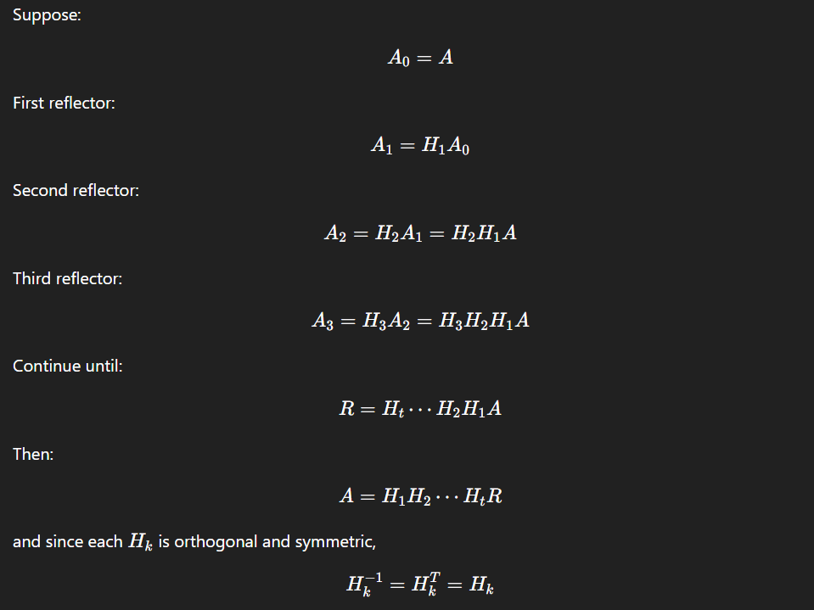
After all steps:
$H_{t} H_{t-1}…H_{1}A=R$
HR = R (R = A in the beginning)
A = (H_1)^T * … * (H_t)^T * R => Q = H_1 * … * H_t =>
Q = I in the beginning; Each time we apply a reflector to R: R = R = HR we must also accumulate it into Q: Q = QH. And Q starts just as a first reflector H (Q = IH = H), then we accumulate the rest
HR reflects rows of R, QH reflects cols of Q.

- Iterating methods Jacobi and Gauss-Seidel. A priori and a posteriori esimation.
Jacobi iteration. B: . We calculate B to find 0 < ||B|| = q < 1(common ratio).
Iterations (Jacobi step for xi):
Stopping rule:

Seidel iteration. B:
Iterations:

